Chapter 7, Solution 2.

Find the time constant for the RC circuit in Fig. 7.82.

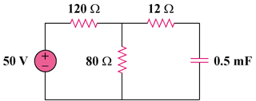

200 mF

Figure 7.82
For Prob. 7.2.

Solution

where is the Thevenin equivalent at the capacitor terminals.

12 s.

